Architecture Design
Concrete Compressive Strength Prediction

Written By | SHREYAS KHADYE  SUDHANSU GOUDA
Version | 1.0
Date | 01/04/2023

Document Control

Change Record:

Version | Date | Author | Comments

Approval Status:

Version | Review  Date | Reviewed By | Approved By | Comments

Index

Content | Page No.
Abstract | 4
1. Introduction | 4
1.1 What is Architecture Design? | 4
1.2 Scope | 4
1.3 Constraints | 4
2. Technical Specification | 5
2.1 Dataset | 5
2.2 Logging | 7
2.3 New Feature Generation | 7
2.4 Deployment | 7
3. Technology Stack | 8
4. Proposed Solution | 8
5. Architecture | 8
5.1 Data Gathering | 9
5.2 Raw Data Validation | 9
5.3 Data Transformatiom | 10
5.4 New Feature Generation | 10
5.5 Data Preprocessing | 10
5.6 Model Building | 10
5.7 Model Saving | 10
5.8 Web app setup | 10
5.9 Github | 11
5.10 Deployment | 11
6. User Input/Output Workflow | 12

Abstract
The quality of concrete is determined by its compressive strength, which is measured using a conventional crushing test on a concrete cylinder. The strength of the concrete is also a vital aspect in achieving the requisite longevity. It will take 28 days to test strength, which is a long period. So, what will we do now? We can save a lot of time and effort by using Data Science to estimate how much quantity of which raw material we need for acceptable compressive strength. The aim is to build a solution that should able to predict the compressive strength of the concrete.

1. Introduction
1.1 What is Architecture Design?
The goal of Architecture Design (AD) or a low-level design document is to give the internal design of the actual program code for the ‘Concrete Compressive Strength Prediction’. AD describes the class diagrams with the methods and relation between classes and program specification. It describes the modules so that the programmer can directly code the program from the document.

1.2 Scope
Architecture Design (AD) is a component-level design process that follows a step-by-step refinement process. This process can be used for designing data structures, required software, architecture, source code, and ultimately, performance algorithms. Overall, the data organization may be defined during requirement analysis and then refined during data design work and the complete workflow.

1.3 Constraints
We only predict the Concrete compressive strength based on Cement, Blast Furnace Slag, Fly Ash, Water, Superplasticizer, Coarse Aggregate, Fine Aggregate, Age

2. Technical Specification
2.1 Dataset
In this dataset there is data about cement, Blast Furnance Slag, Fly Ash, Water, Superplasticizer, Coarser Aggregate, Fine Aggregate, Age which gives us a variety of combinations of data. Using all the observations it is inferred what role certain properties of concrete play and how they affect the Compressive Strength of concrete. The dataset looks like as follow:

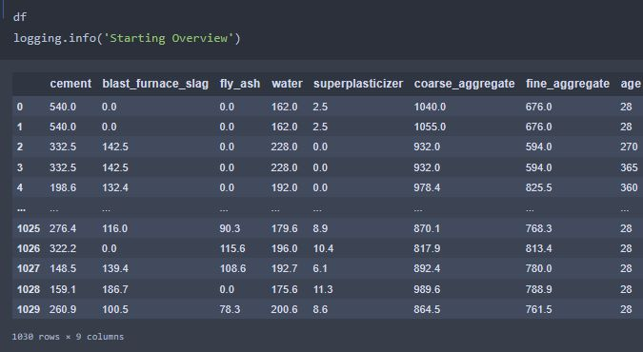

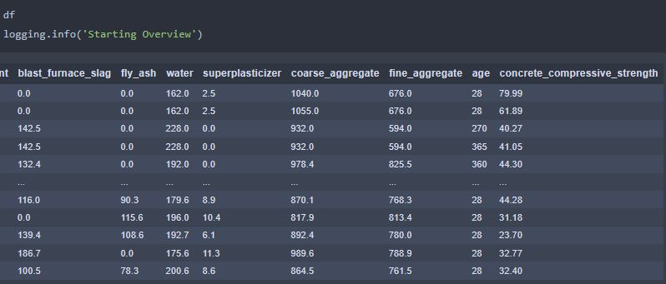

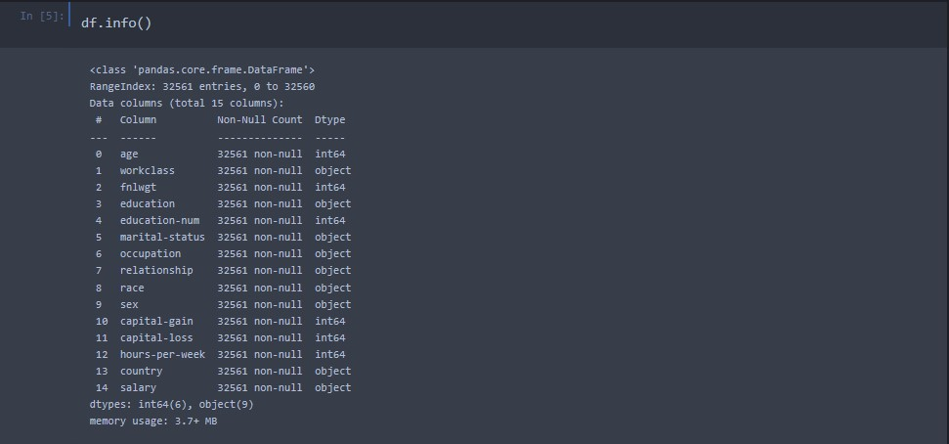
The data set consists of various data types from integer to floating to object as shown 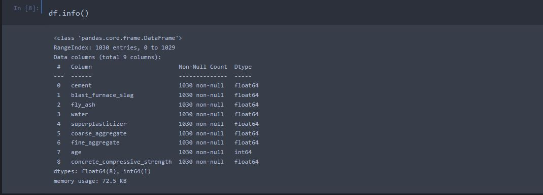

In the raw data, there can be various types of underlying patterns which also gives an in-depth knowledge about the subject of interest and provides insights into the problem. But caution should be observed with respect to data as it may contain null values, or redundant values, or various types of ambiguity, which also demands pre-processing of data.

The dataset should therefore be explored as much as possible.
Various factors important by statistical means like mean, standard deviation, median, count of values and maximum value, etc. are shown below for numerical attributes.

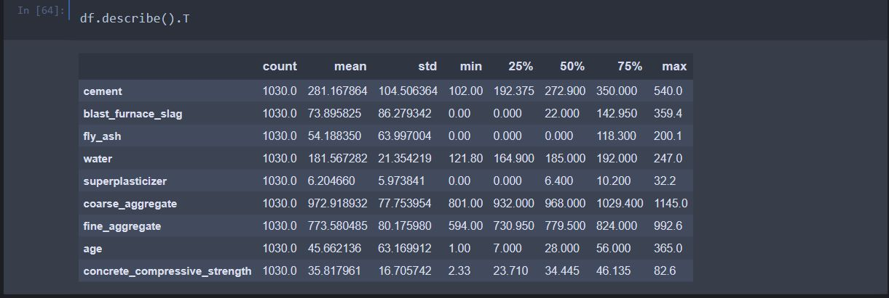

Preprocessing of this dataset includes doing analysis on the independent variables like checking for null values in each column and then replacing or filling them with supported appropriate data types so that analysis and model fitting is not hindered from their way to accuracy. Shown above are some of the representations obtained by using Pandas tools which tell about variable count for numerical columns and model values for categorical columns. Maximum and minimum values in numerical columns, along with their percentile values for median, play an important factor in deciding which value to be chosen at priority for further exploration tasks and analysis. Data types of different columns are used further in label processing and a one-hot encoding scheme during the model building.

2.2 Logging
We should be able to log every activity done by the user
- The system identifies at which step logging require.
- The system should be able to log each and every system flow.
- Developers can choose logging methods. Also, can choose database logging.
- The system should be not be hung even after using so much logging. Logging just because we can easily debug issuing so logging is mandatory to do.

2.3 Database
The system needs to store every request into the database and we need to store it in such a way that it is easy to retain and look into the records.
The system should capture every data that any user gave and the prediction that has been made by that input.

2.4 Deployment
For the deployment process, we will be using Streamlit Sharing cloud to Deploy our model. Streamlit is used to make web apps as well as a cloud platform that lets companies build, deliver, monitor and scale apps.


3. Technology Stack

Web App | Streamlit
Back End | Python
Deployment | Streamlit Sharing

4. Proposed Solution
We will use Exploratory Data Analysis (EDA) to find the Key relations between different attributes and will use a ML algorithm to predict the future sales demand. We can tell the company what are all the challenges they may face, what are the brands or products which is sold the most & other such kind of things, this helps sales team to understand which product to sell & which product to promote & other such kind of things.
The proposed solution for concrete compressive strength prediction involves developing advanced computational models that can accurately predict the strength of concrete based on various input parameters. These models can leverage machine learning algorithms, artificial intelligence, and other advanced data analytics techniques to provide reliable and precise predictions.

5. Architecture
Process Flow

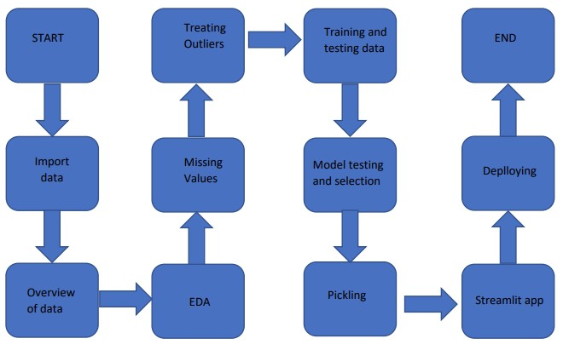

5.1 Data Gathering
Data source:
https://www.kaggle.com/datasets/elikplim/concrete-compressive-strength-data-set

5.2 Raw Data Validation
After data is loaded, various types of validation are required. Validations like checking for zero standard deviation for all the columns, checking for complete missing values in any columns, etc. These are required because The attributes which contain these are of no use. It will not be much of use in determining of the salary category.
Like if any attribute is having zero standard deviation, it means that’s all the values are the same, its mean is zero. Missing data in the training data stands as a problem in front of us.

5.3 Data Transformation
Before sending the data into the database, data transformation is required so that data are converted into such a form with which it can easily be inserted into the database. Here, the ‘blast_ furnance_slag’ ,‘fly_ Ash’ and ‘superplasticizer’ attributes contain a vast amount of missing values. So, they have been replaced them with the respective mean values.

5.4 New Feature Generation
We haven’t derived a new category.

5.5 Data Pre-processing
In data pre-processing all the processes required before sending the data for model building are performed. Like, here ‘blast_ furnance_slag’ ,‘fly_ Ash’ and ‘superplasticizer’ the attributes are having some values equal to 0,no doubt both of these attributes are viable for prediction due to maximum entry being zero in the model they can’t contribute much. So they have been replaced with the respective mean values. We also detected some outliers with the help of bar chart and replaced them with the respective mean values.

5.6Model Building
After doing all kinds of preprocessing operations mention above and performing model training and testing the accuracy we came to the conclusion that Lasso Regression have the highest accuracy with 93% accuracy.

5.7 Model Saving
Model is saved using pickle library in ‘.pkl’ format.

5.8 Web app setup
After saving the model in .pkl file format we then create an app.py streamlit web app framework (Written in python) and then use requests to extract all the form selection selected by the user and then we predict the concrete compressive strength by using the selected records by the user.

5.9 GitHub
The whole project directory will be pushed into the GitHub repository.
GitHub Project link: https://github.com/ShreyasKhadye/Concrete-Compressive-Strength-Prediction

5.11 Deployment
The cloud environment was set up and the project was deployed from GitHub into the streamlit platform.
WebApp link - https://shreyaskhadye-concrete-compressive-strength-predicti-app-l56p7u.streamlit.app/

6. User Input / Output Workflow.

